The $3tr question, Mar 13, 2021
-Economic controls of WW2 in the US: the government rationed everything from coffee to shoes and forbade the production of fridges and bicycles; in 1943 it produced only 139 cars. When the war ended American’s put to use the personal savings they had accumulated in wartime. By 1950 more than 8m cars a year were produced (vs. 4.5m in 1929 and 1m in 1933).
- Since March 2020, governments in the rich world have spent 5% of their combined GDP on furlough schemes, unemployment benefits and stimulus cheques. As a result, household incomes have risen in the past year. At the same time, lockdowns have reduced opportunities to spend.
- The result: in 21 rich countries households accumulated $6tr of savings in the first 9 months of 2020 - $3tr in excess of what would have happened without the pandemic. This excess is a tenth of annual consumer spending in those countries. In America excess saving will exceed 10% of GDP because of the $1.9tr stimulus.
- In all rich countries wealthier people have accumulated most of the excess savings. A big share of their spending is discretionary, say on holidays and meals out; and its many of these services that have been shut down since March 2020. A large chunk of savings in the hands of the rich limits the potential for a post-lockdown bonanza.
- Yet the pro-rich skew in savings is larger in Europe than in America. The poorest quarter European households have been half as likely to increase their savings as the richest. By contrast, in America top-ups to unemployment benefits made many people who lost work earn more than they done in their jobs. Thus, low-income Americans may have saved even more than the rich, relative to their incomes. So post-lockdown C is likely to increase more in America than in Europe.
- Second difference: households in Europe have built up excess savings by spending less; in America and Japan excess savings are also a result of higher income because of stimulus payouts. Consumers may be happier spend the excess in this second case (for purely psychological reasons). A 2nd reason why post-lockdown C is likely to increase more in America than in Europe.
-The post WW2 America’s boom was impressive enough, but Europe’s was even more so, with GDP growth running 50% faster throughout the 1950s. But now, when the pandemic wanes, it is America where more stimulus is in place and where consumers are likelier to spend the excess savings accumulated in 2020 that will grow faster than Europe.
Biden’s gamble, March 13, p. 7
-The $1.9tr stimulus bill takes to nearly $3tr (14% of pre-crisis GDP) the amount of pandemic related spending passed since Dec., and to about $6tr the total paid since March 2020.
- The government will also pour $2.5tr into the banking system this year.
- For a decade after the GR America’s policymakers were too timid.
- In Jan America’s retail sales were already 7.4% higher than a year earlier, as most Americans received stimulus $600 cheques from the government. Stuck at home, consumers have accumulated $1.6tr in excess savings during the past year. Biden is giving most Americans another $1,400 each. Unusually for a rich country, a big chunk of the cash pile is held by poor households that are likely to spend it once the economy reopens.
- The trade deficit is already 50% larger than before the pandemic as the economy sucks in M. There are still 9.5m jobs missing but U should fall below 5% by the end of this year. This quick recovery from an U rate that jumped to near 15% in April 2020 contrasts with the puny recovery after 2009. GDP will be larger in 2022 than predicted before the pandemic.
- Today’s economic experiment features historic levels of stimulus, a more tolerant attitude at the Fed towards temporary overshoots in inflation (under its ‘average inflation targeting’ regime adopted last August it seeks to bring about inflation over its 2% target in order to make up for past shortfalls) and huge pent-up savings. The danger is that the economy overheats. Ten-year bond yields have risen by about one pp since last summer on expectations of higher inflation and interest rates.
- Given America’s pivotal role in the global financial system, this has already spilled across borders. Australia’s CB has had to increase its bond purchases to prevent yields from rising too much. The ECB is likely to do the same.
- The Fed may have to raise rates to get inflation down. Higher rates would puncture asset markets and increase the burden on public debt.
- Thanks to extra cash for most parents, the country’s persistent and widespread child poverty will fall dramatically.

Fiscal stimulus in America, Feb 6, p.8 and p. 31
-America will recover faster than its rich-world peers because of its enormous stimulus which boosted households’ incomes by more than 6% in 2020.
-On top of the $4tr stimulus approved in 2020, Biden proposes a further $1.9tr, including $0.5tr in cheques. The total – almost $6tr – is equal to 25% of the GDP of 2019.
But only half of that is needed for what is needed:
- Vaccinations ($0,15tr),
- An extension of the $300 top-up on UI ($0.3tr) beyond March,
- One-off cheques of $,1000 (instead of $1,400) and only for people making less than $50,000.
- A temporary boost to child-tax credit.
- The $0.35tr for state and local governments is not needed. In the first wave there was the fear that their tax revenues would collapse and they would lay-off workers. But the generous UI benefits – because of social distancing – were mainly spent on goods and boosted their tax receipts.
- The full reopening of the economy in the second half of the economy coupled with the pent-up demand from the savings of stimulus money may lead to a burst of inflation

Will America overheat? Jan 23, p. 55
- 2020 stimulus (before Dec): $ 3tr (14% of 2019 GDP), of which $0.6tr (SBs), $0.5tr (UI), $0.3tr (cheques) and $0.3tr (state and local aid).
- Stimulus approved in Dec: $0.9 tr of which $0.3tr (SBs), $0.1tr (UI) and $0.2tr (cheques).
-Biden’s plan: $1.9tr, 9% of 2019 GDP, of which $0.4tr (SBs), $0.35tr (UI), $0.5tr (cheques) and $0.3t5r (state and local aid).

- The 2020 stimulus (before Dec) 14% of 2019 GDP was bigger than the shortfall in output; but social distance meant that half this cash was kept in bank accounts.
- The number of non-farm jobs remain 6.3% below the pre-pandemic level, similar to the shortfall of 2010. Rather than spread widely, economic disruption is concentrated in leisure and hospitality.
- The Biden’s stimulus plan ($1.9tr = 9% of 2019 GDP) is twice that of Obama in 2009; and, given the context – a stimulus in Dec of $0.9tr + $1.6tr of excess savings from the first stimulus = $2.5tr = 12% of 2019 GDP) is much bigger than the shortfall in demand and, “once we have covid behind us will put the economy on fire” (Summers).
- MP will remain loose: “the Fed’s rates will not rise soon” (Powell); and the Fed will not taper its $200b monthly purchases of Treasuries and MBS. Fed’s rates will not rise before inflation moderately exceeds 2% for some time to make up for the continued previous shortfalls.
Low interest rates underpin today’s sky-high asset price and the sustainability of rocketing public debt.

$900b US fiscal stimulus, Jan 2, p. 9
-US public debt:
40% GDP (2000-08)
75-80% GDP (2009-19)
100% GDP (2020)
-The fiscal stimulus passed in March 2020, $2.2tr, increased government expenditure in 2020 by 50% compared with 2019.
- Households’ incomes increased, C fell and the saving sate went up. Poverty was cut by 15%. But the provisions expired on July 31 and poverty returned to the old levels.
- It took 6-months for Democrats and Reps agree this week on a new stimulus. This is worth $900b and includes a cheque of $600 to most Americans and a top-up of unemployment benefits by $300 a week (from $400 to $700) until March. A moratorium on evictions will be extended.
The stalemate highlighted the need for stimulus measures to kick in automatically when the economy is weak.

The Euro area – less stingy than during the global and sovereign-debt crises, June 20, 2020
-In the first three weeks of June alone, the ECB said it would add to the initial expanded QE of €750b another €600bn in bonds. National leaders proposed a EU-wide “recovery fund” of €750b.
- The challenge: countries facing the greatest economic damage are also those with the least fiscal space. Germany’s outbreak was relatively less severe, and its lockdowns less stringent. Its new programme takes its total fiscal stimulus this year to 9% of GDP. But France, Italy and Spain, which have had worse outbreaks and stricter lockdowns, and will lose tourism revenues over the summer, also have higher government-debt ratios. Fiscal support has been stingier there.
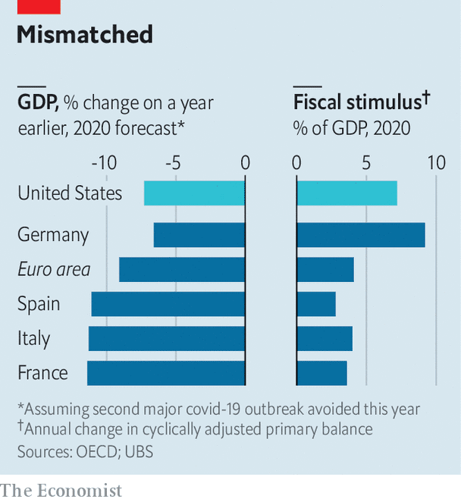
-To redress the imbalance, the EU-wide “recovery fund” of €750b will direct cash to countries according to need rather than what they contribute: Italy could receive grants equivalent to about 5% of its GDP, and loans worth another 5%. Germany and the Netherlands might receive funds worth only 1% of GDP. But the cash will only begin to be doled out in 2021, and will be spread over seven years.
- This means that the ECB must do the heavy lifting this year. All told, it is due to buy €1.6trn in public and private-sector debt in 2020, equivalent to 14% of last year’s GDP. Instead of buying bonds in line with a country’s contribution to its capital (its ‘capital key’, proportional to its GDP), the ECB seeks to contain the spread between the bond yields of riskier countries and those on German bunds. 22% of the purchases in April and May were of Italian paper, whereas Italy’s share of the capital key is 17%. The ECB could thus indirectly fund all of Italy’s deficit this year.

